EXPERIMENT – 6
PARSEVAL'S RELATION AND HARMONIC SPECTRUM ANALYSIS

OBJECTIVE :
(i) To verify Parseval’s relation for continuous-time periodic signals and analyze the
relationship between time-domain and frequency-domain power.
(ii) To compare the total power obtained in the time domain with the harmonic power
distribution in the frequency domain.

MATLAB CODING :
clc; clear; close all;
%% 6(i) Verification of Parseval’s Relation for Periodic Signals
figure;
% Verification of Parseval's Relation
f0 = 1;
T = 1/f0;
t = linspace(0,T,4000);
x = max(sin(2*pi*f0*t),0);
% Time-domain average power
P_time = (1/T)*trapz(t,abs(x).^2);
% Fourier-series coefficients
N = 20;
a0 = (2/T)*trapz(t,x);
an = zeros(1,N); bn = zeros(1,N);
for k = 1:N
an(k) = (2/T)*trapz(t,x.*cos(2*pi*k*f0*t));
bn(k) = (2/T)*trapz(t,x.*sin(2*pi*k*f0*t));
end
% Frequency-domain power using Parseval's relation
P_freq = a0^2/4 + 0.5*sum(an.^2 + bn.^2);
fprintf('Time-domain power = %.6f\n',P_time);
fprintf('Frequency-domain power = %.6f\n',P_freq);
fprintf('Absolute error = %.6e\n',abs(P_time-P_freq));
bar([P_time P_freq]);
set(gca,'XTickLabel',{'Time Domain','Frequency Domain'});
ylabel('Average Power'); grid on;
title('Verification of Parseval''s Relation');

MATLAB CODING :
clc; clear; close all;
%% 6(iv) Comparison of Time-Domain Power with Frequency-Domain Harmonic Power
figure;
% Time-Domain and Frequency-Domain Power Comparison
f0 = 1; T = 1/f0;
t = linspace(0,T,4000);
x = max(sin(2*pi*f0*t),0);
P_time = (1/T)*trapz(t,x.^2);
N = 20;
a0 = (2/T)*trapz(t,x);
an = zeros(1,N); bn = zeros(1,N);
for k = 1:N
an(k) = (2/T)*trapz(t,x.*cos(2*pi*k*f0*t));
bn(k) = (2/T)*trapz(t,x.*sin(2*pi*k*f0*t));
end
P_dc = a0^2/4;
P_harmonics = 0.5*sum(an.^2+bn.^2);
P_frequency = P_dc + P_harmonics;
fprintf('Time-domain power = %.6f\n',P_time);
fprintf('DC power = %.6f\n',P_dc);
fprintf('Harmonic power = %.6f\n',P_harmonics);
fprintf('Frequency-domain power = %.6f\n',P_frequency);
bar([P_time P_frequency]);
set(gca,'XTickLabel',{'Time Domain','Frequency Domain'});
ylabel('Average Power'); grid on;
title('Time-Domain vs Frequency-Domain Power');

OUTPUT :
To verify Parseval’s relation for continuous-time periodic signals and analyze the
relationship between time-domain and frequency-domain power.
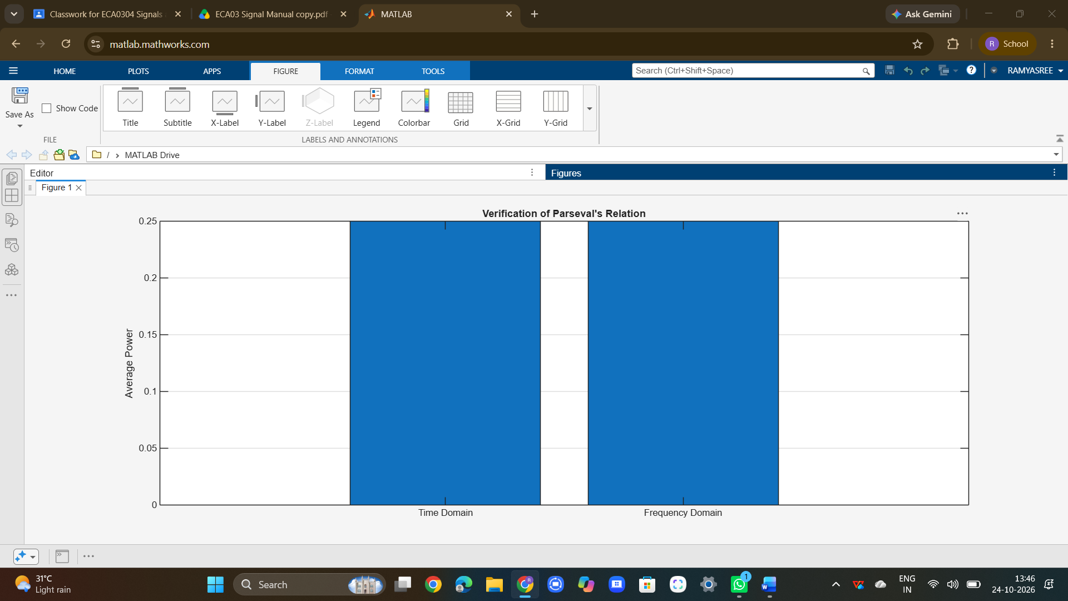

To compare the total power obtained in the time domain with the harmonic power
distribution in the frequency domain.
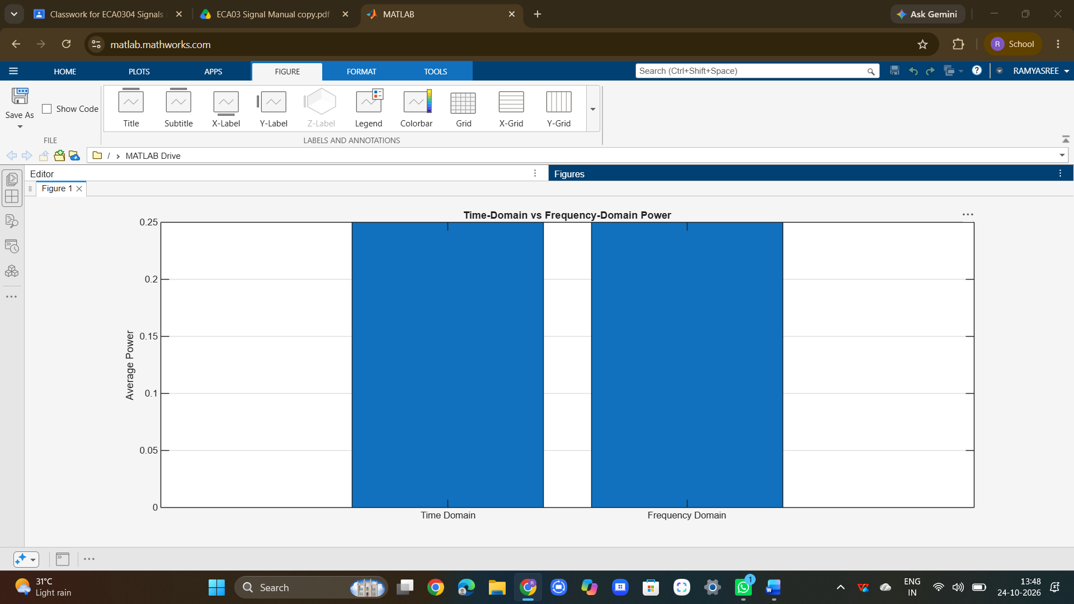

RESULT :
The experiment successfully verified Parseval’s relation for continuous-time periodic signals by demonstrating the equivalence of power calculated in the time and frequency domains. The distribution of power among the fundamental and harmonic components was analyzed through the harmonic spectrum, and the total time-domain power was found to be consistent with the sum of harmonic powers in the frequency domain.

